The American Student, #2



Proven Study Techniques

*By*

Michael Grandelli and Zelda McEvoy

12

Mid-term exams are stressful. In many courses, they may be the first written exam you can take and count for as much as one-third of your grade. They give you an opportunity to demonstrate how much you know, but also to check your understanding of the material. There are a few proven study techniques that you can use in order to ensure that you are successful and achieve the best grade you can.

14

13

Scroll down to view the second source



February 2015 #2

The Mid-Term

Exam

EXATRAVAGANZA

!!!

Proven Study Techniques:

Our top staff writers walk you through the techniques that boost grades

The American

Student

Study Spaces Ranked:

Where is the best place to review?

PLUS:

Flashcards, study schedules, and other tools to help prepare



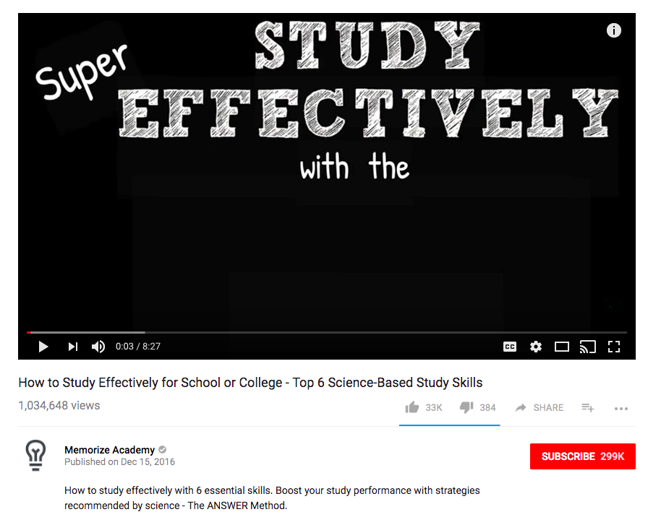

Studying for Tests: Don’t Cram

With

Thomas Lynch



Studying for Tests: Don’t Cram

ProfTom

Published: March 8, 2016

Learn the dos and don’ts of study preparation!